201801-201808，向上跳空缺口，剔除新股和涨幅超过9%

亏损超过7%

## 长盛轴承

|  |  |  |  |
| --- | --- | --- | --- |
| 2018/7/13 | 300718 | 长盛轴承 | **-12.18%** |

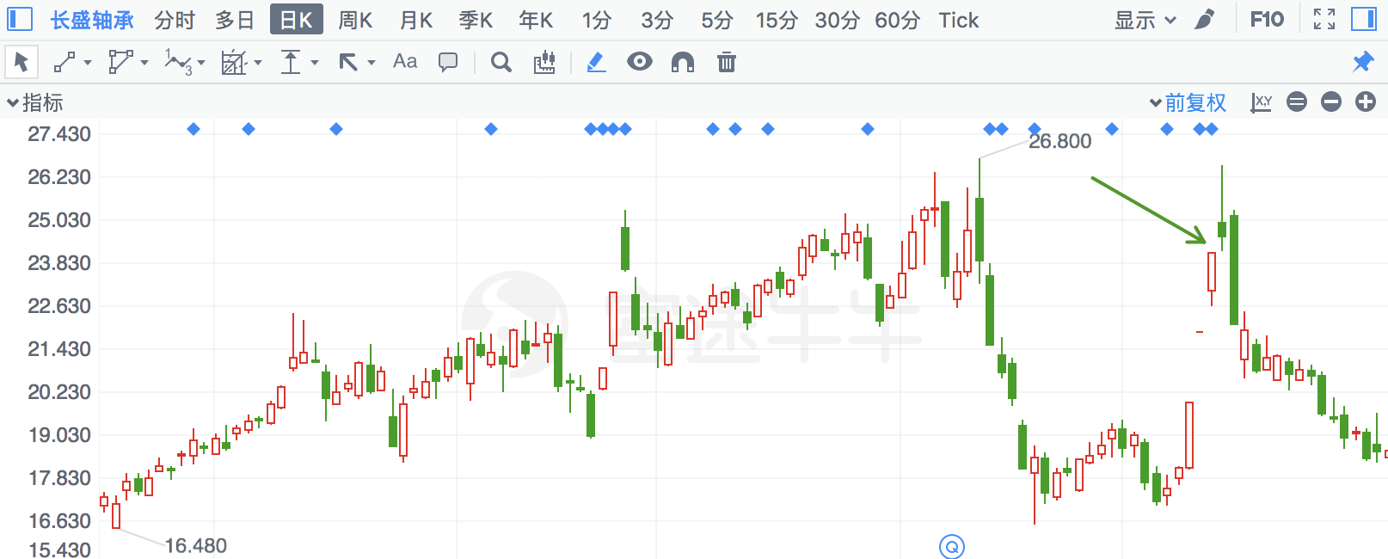

## 晓程科技

|  |  |  |  |
| --- | --- | --- | --- |
| 2018/7/2 | 300139 | 晓程科技 | **-10.80%** |

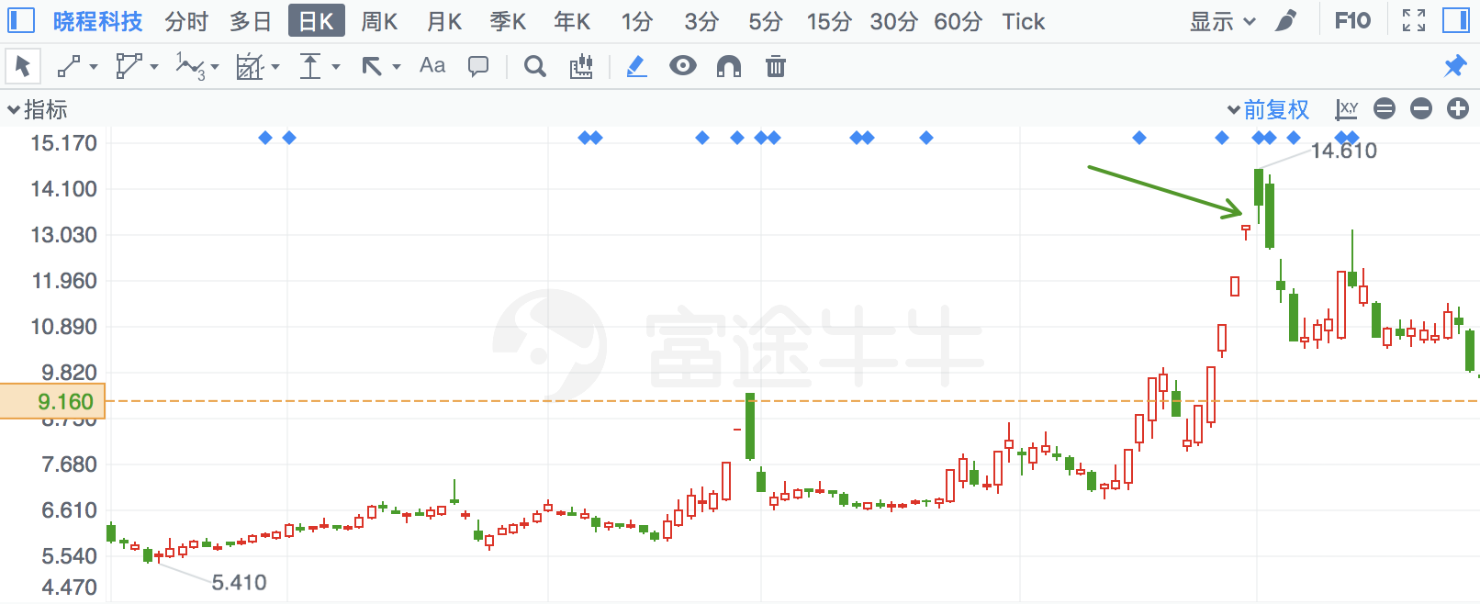

## 宏达矿业

|  |  |  |  |
| --- | --- | --- | --- |
| 2018/7/13 | 600532 | 宏达矿业 | **-10.63%** |

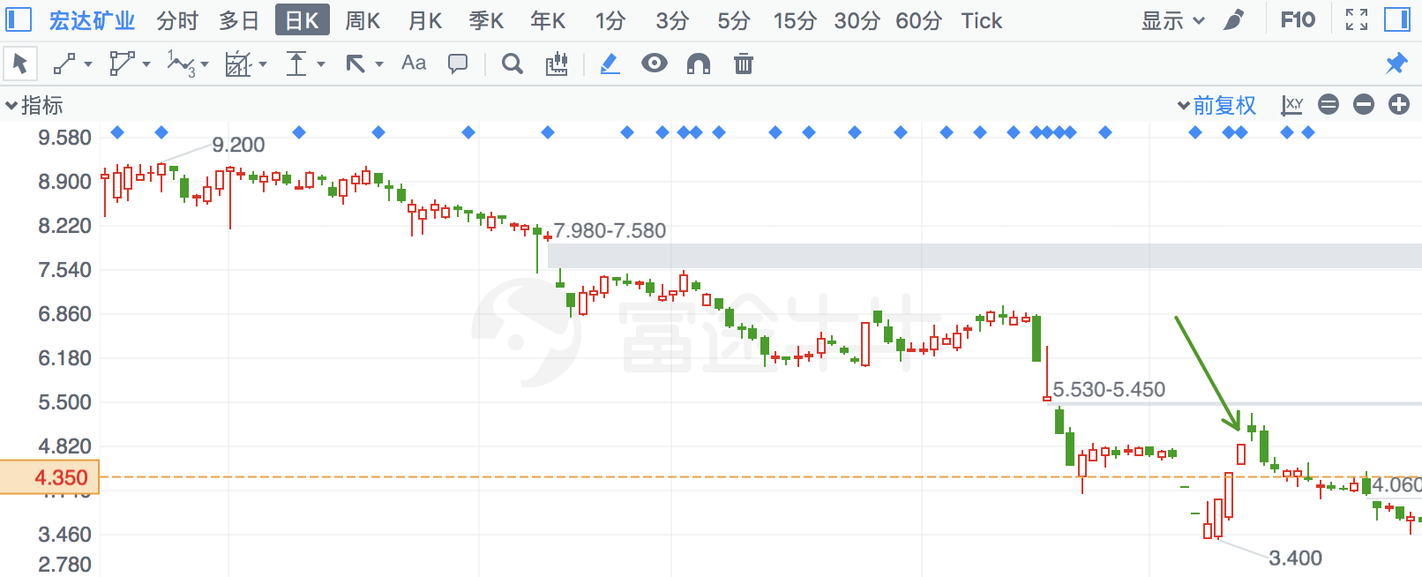

## 花王股份

|  |  |  |  |
| --- | --- | --- | --- |
| 2018/1/31 | 603007 | 花王股份 | **-10.49%** |

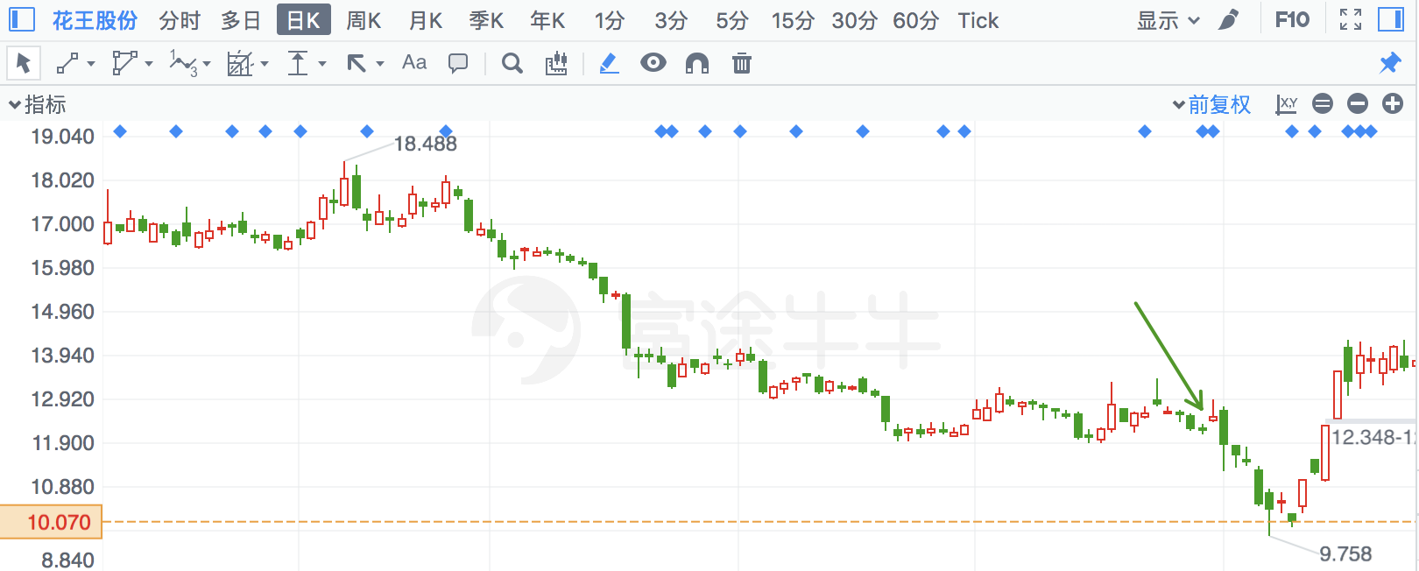

## 镇海股份

|  |  |  |  |
| --- | --- | --- | --- |
| 2018/7/19 | 603637 | 镇海股份 | **-10.36%** |

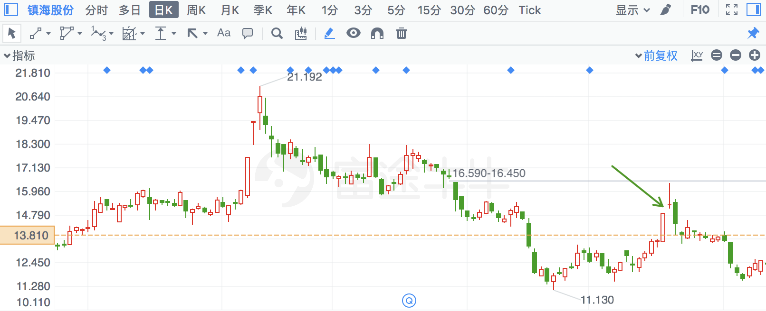

## 旭升股份

|  |  |  |  |
| --- | --- | --- | --- |
| 2018/5/14 | 603305 | 旭升股份 | **-10.34%** |

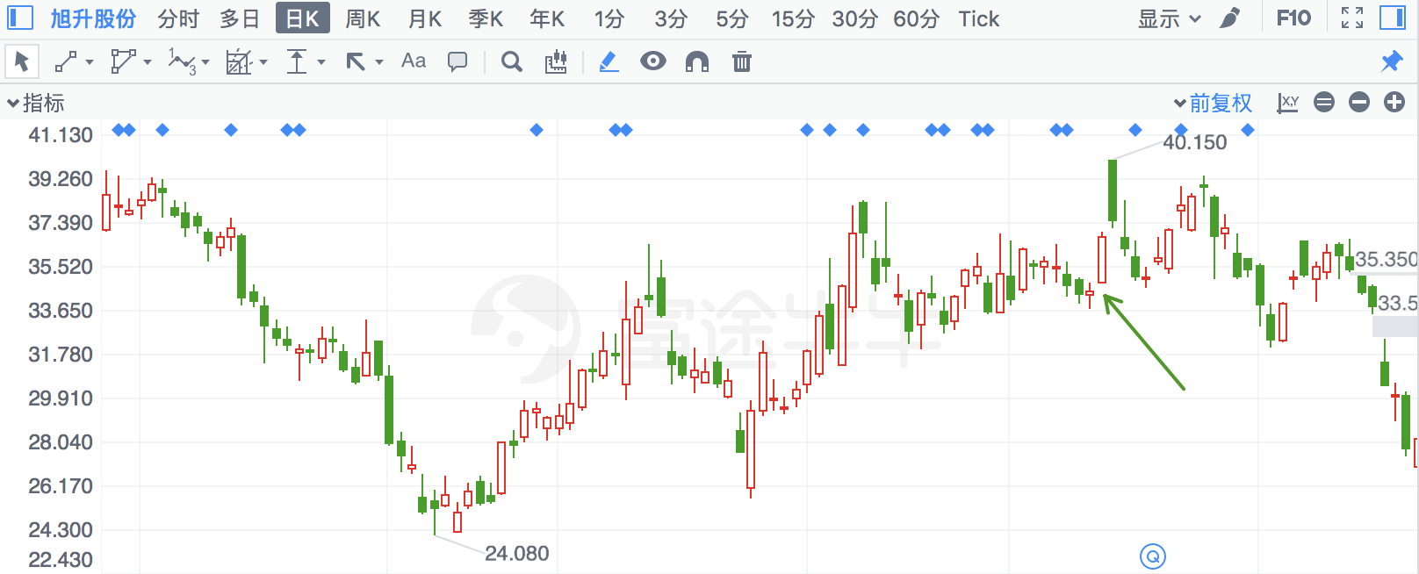

## *ST慧业

|  |  |  |  |
| --- | --- | --- | --- |
| 2018/2/13 | 816 | *ST慧业 | **-10.30%** |

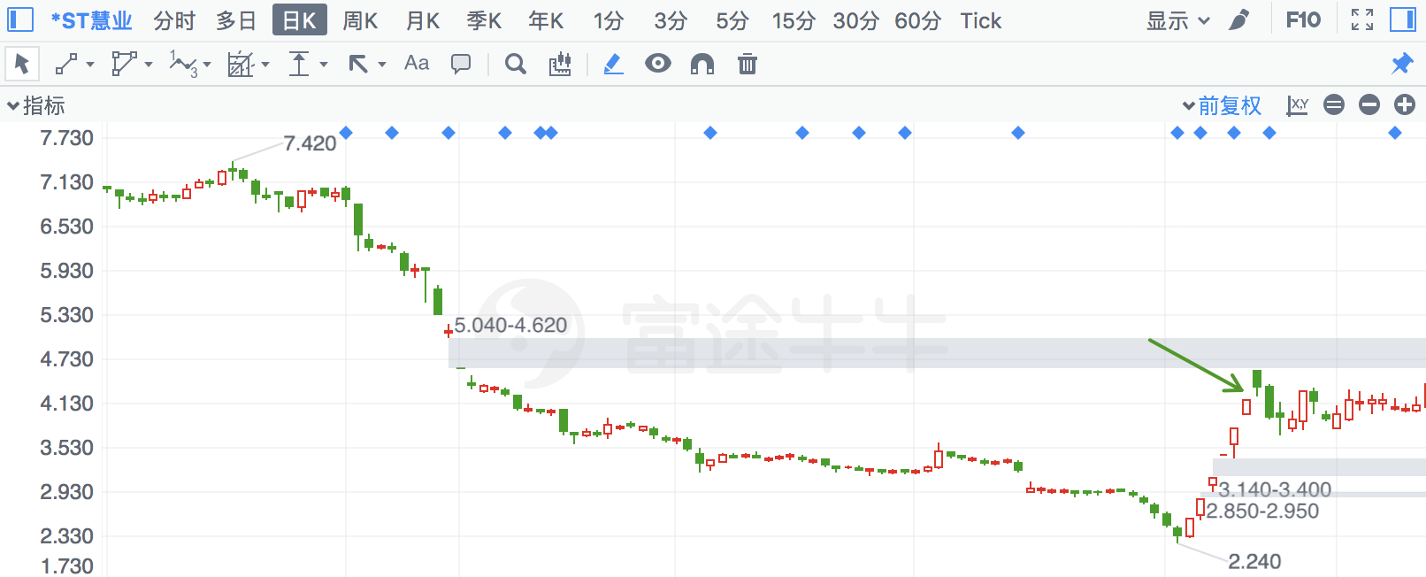

## 普莱柯

|  |  |  |  |
| --- | --- | --- | --- |
| 2018/4/10 | 603566 | 普莱柯 | **-9.25%** |

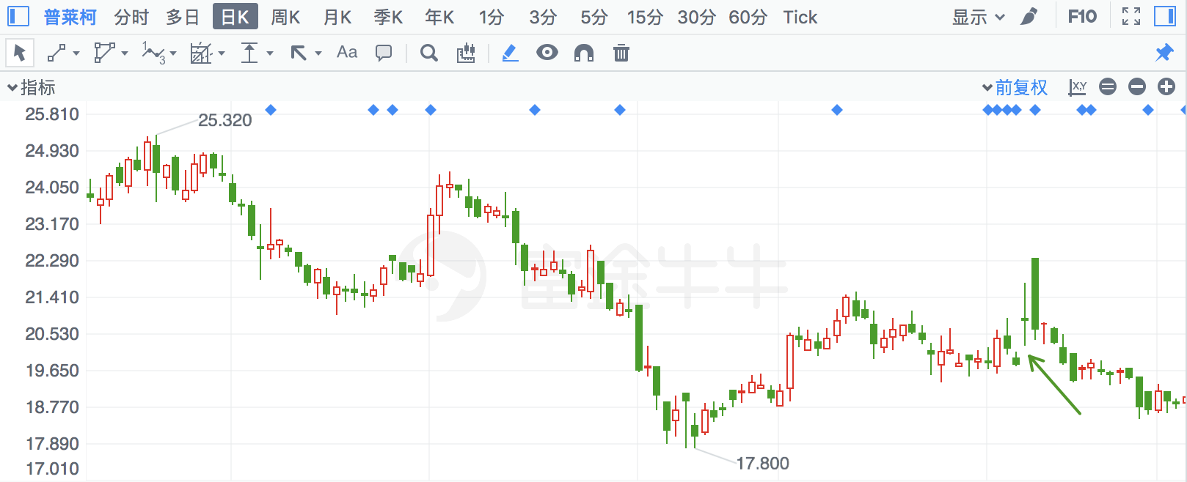

## 华大基因

|  |  |  |  |
| --- | --- | --- | --- |
| 2018/7/4 | 300676 | 华大基因 | **-9.17%** |

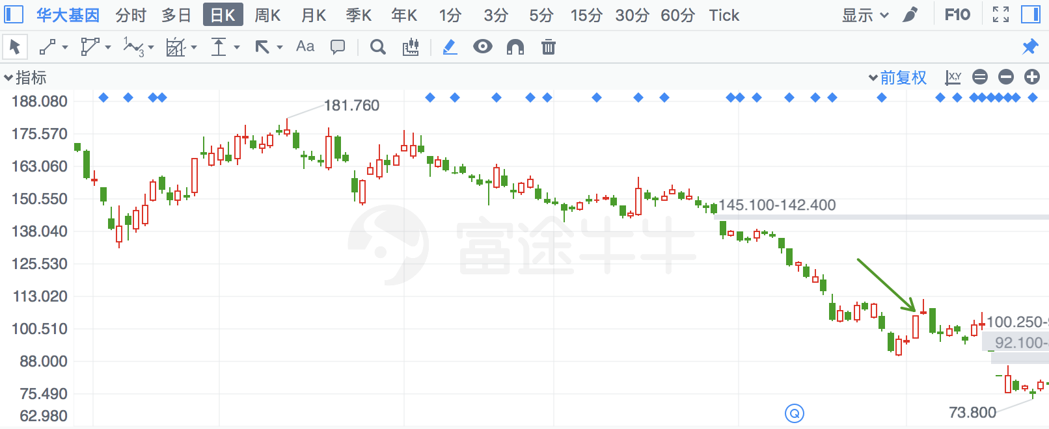

## 杭州高新

|  |  |  |  |
| --- | --- | --- | --- |
| 2018/1/8 | 300478 | 杭州高新 | **-9.02%** |

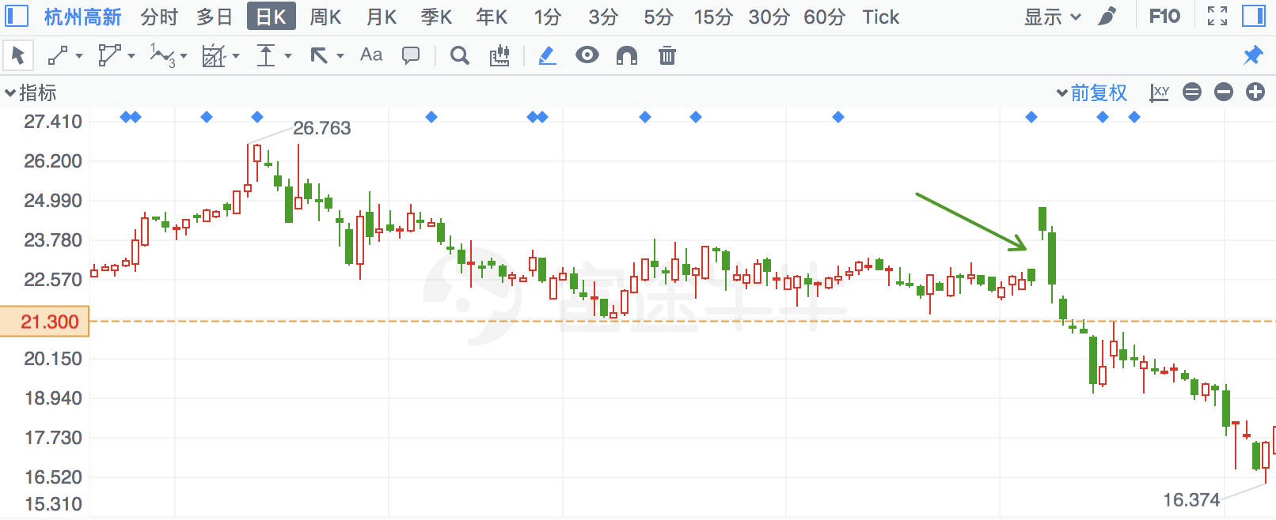

## 阳光股份

|  |  |  |  |
| --- | --- | --- | --- |
| 2018/1/25 | 608 | 阳光股份 | **-8.98%** |

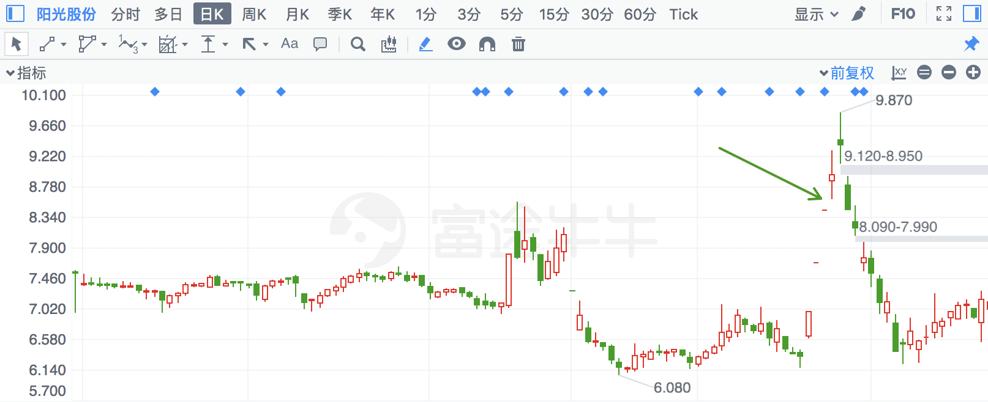

## 真视通

|  |  |  |  |
| --- | --- | --- | --- |
| 2018/4/16 | 2771 | 真视通 | **-8.77%** |

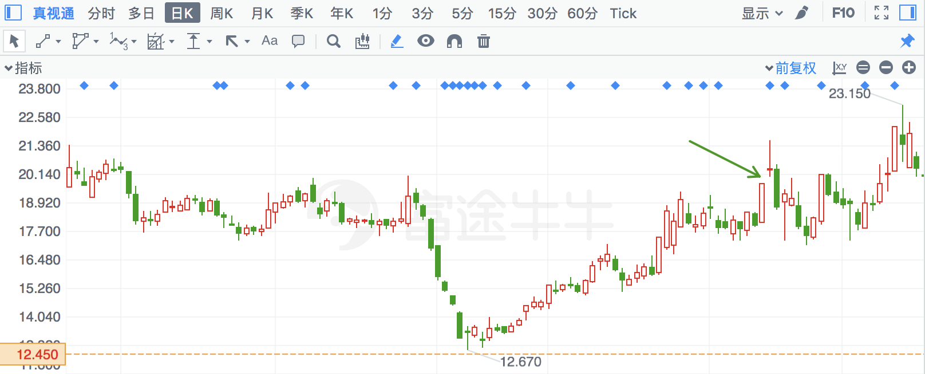

## 杭州园林

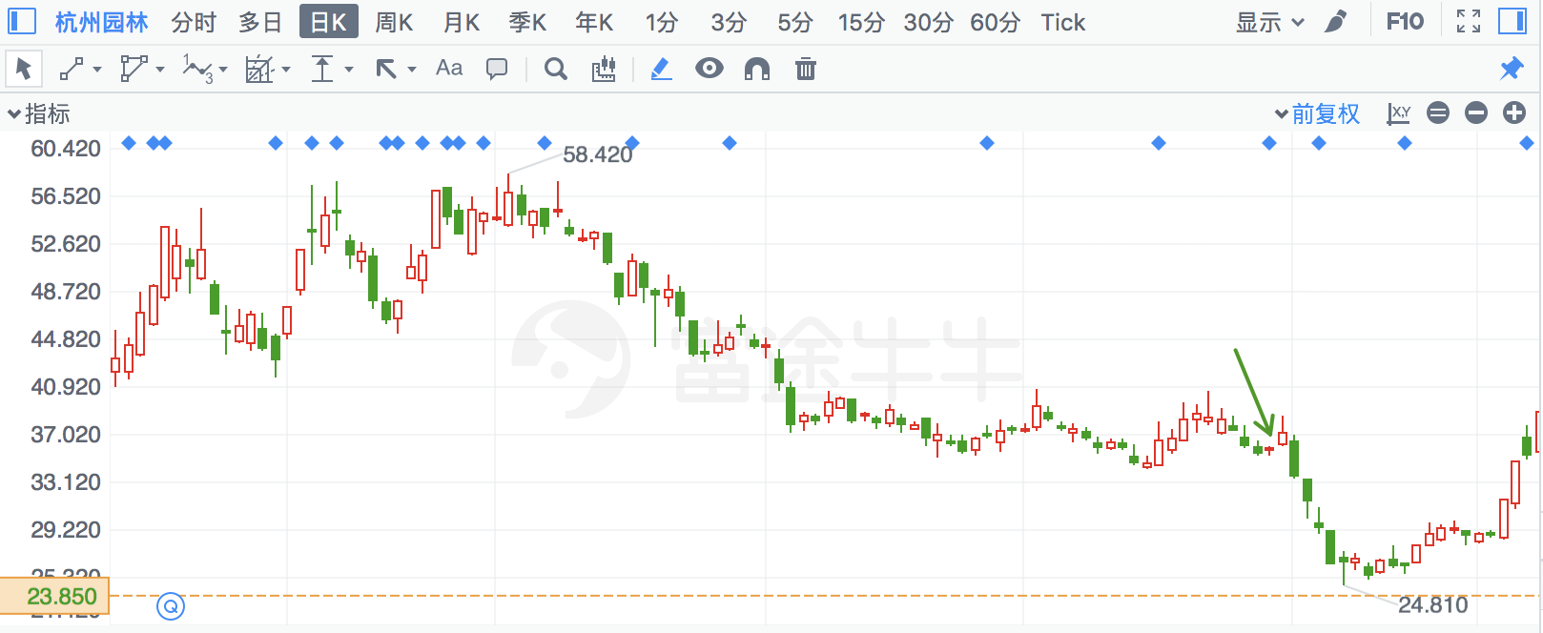

## 盈趣科技

|  |  |  |  |
| --- | --- | --- | --- |
| 2018/1/31 | 2925 | 盈趣科技 | **-8.60%** |

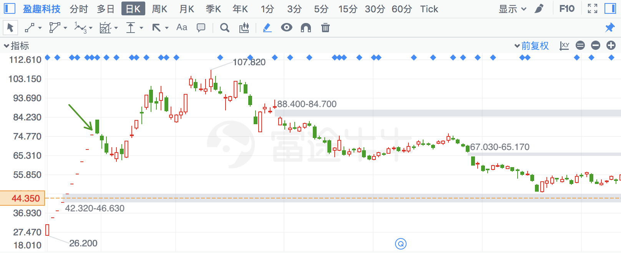

## 安居宝

|  |  |  |  |
| --- | --- | --- | --- |
| 2018/2/12 | 300155 | 安居宝 | **-8.20%** |

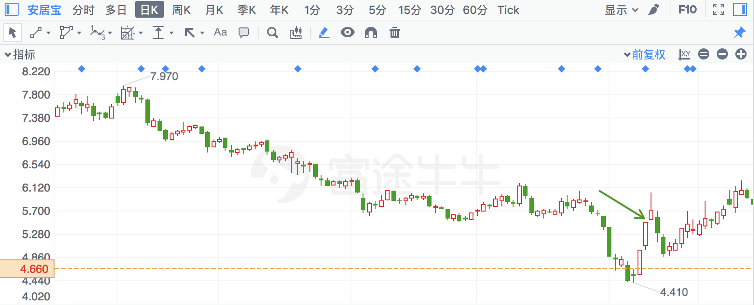

## 北大荒

|  |  |  |  |
| --- | --- | --- | --- |
| 2018/3/23 | 600598 | 北大荒 | **-8.16%** |

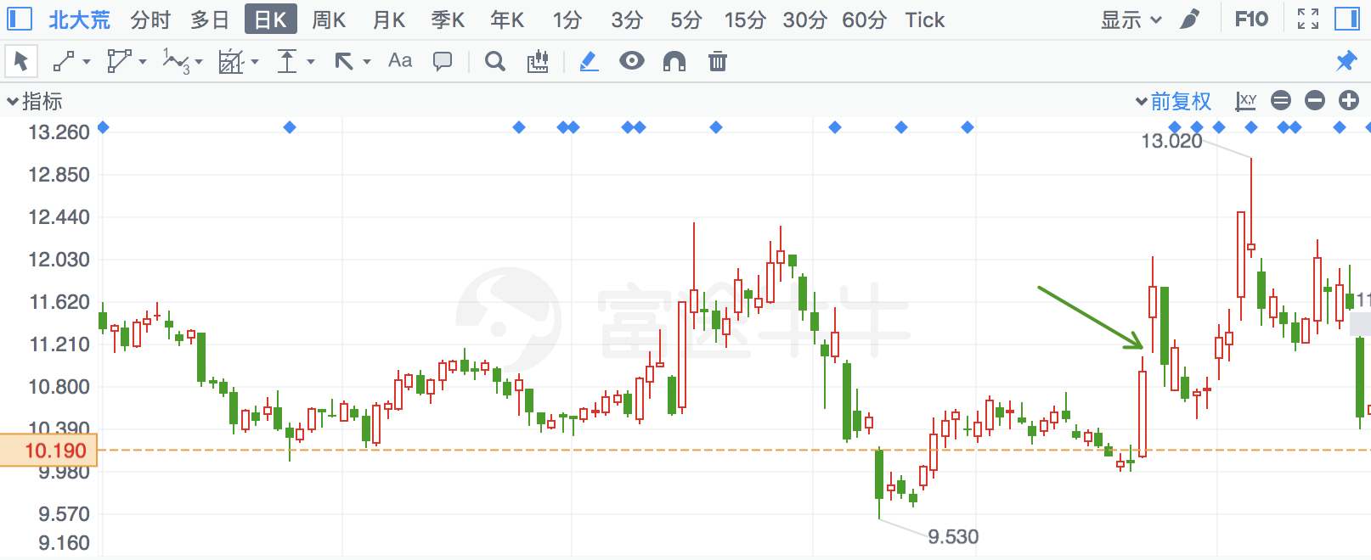

## 铭普光磁

|  |  |  |  |
| --- | --- | --- | --- |
| 2018/4/17 | 2902 | 铭普光磁 | **-8.14%** |

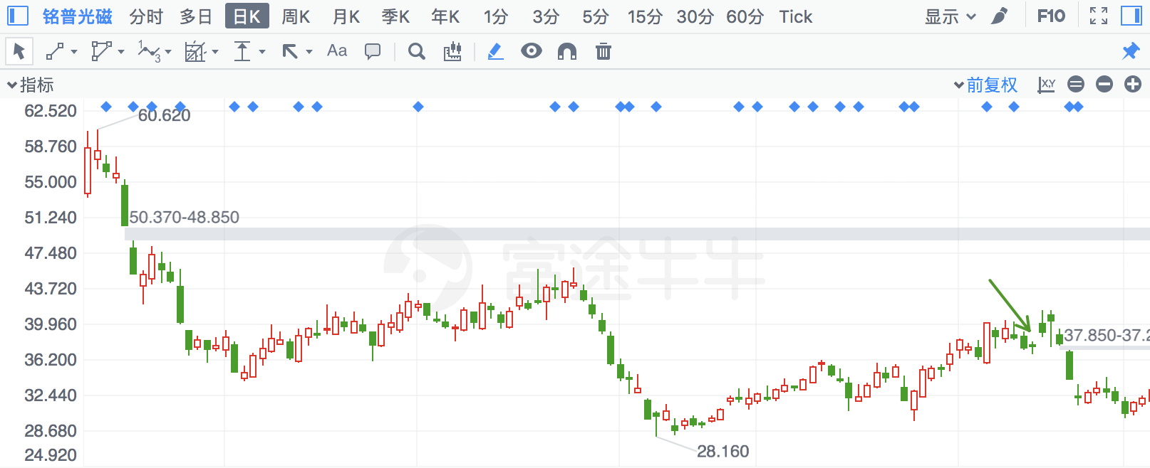

## 浙数文化

|  |  |  |  |
| --- | --- | --- | --- |
| 2018/4/26 | 600633 | 浙数文化 | **-8.12%** |

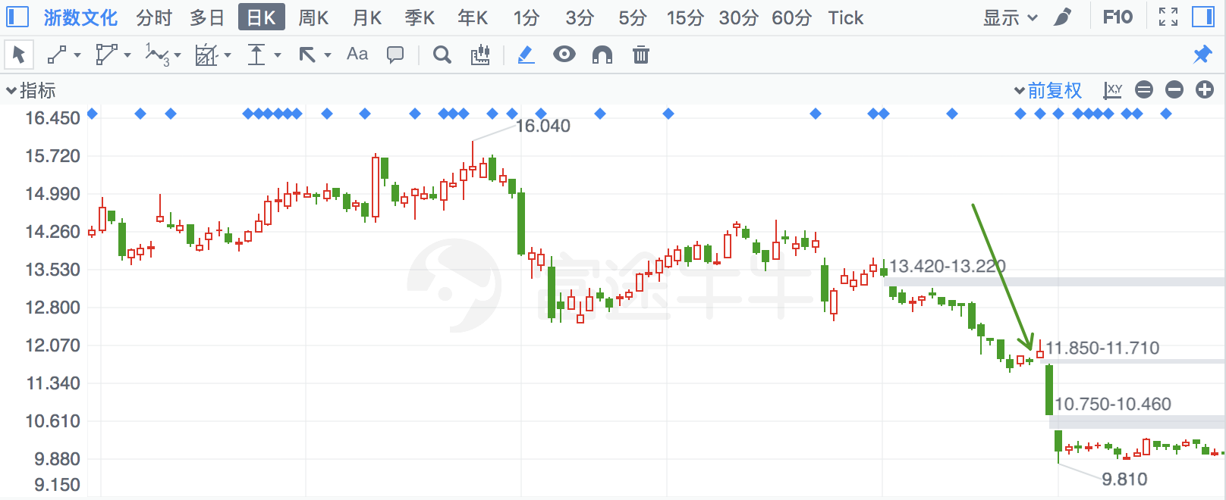

## 世嘉科技

|  |  |  |  |
| --- | --- | --- | --- |
| 2018/6/6 | 2796 | 世嘉科技 | **-8.11%** |

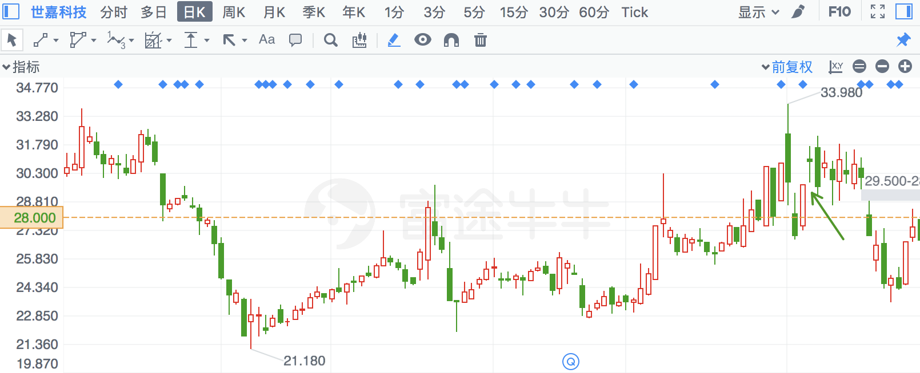

## 通威股份

|  |  |  |  |
| --- | --- | --- | --- |
| 2018/3/21 | 600438 | 通威股份 | **-8.06%** |

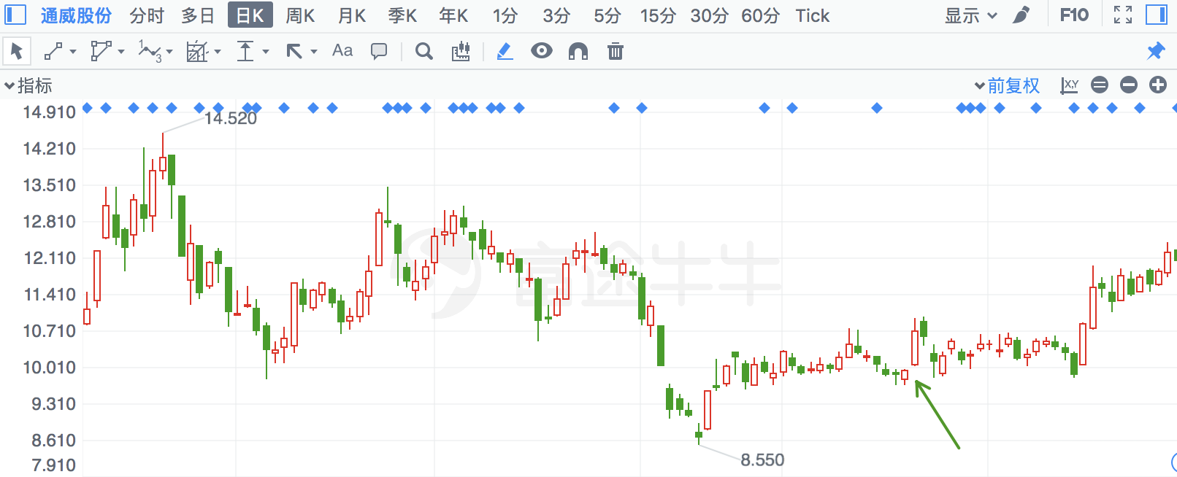

## 建新股份

|  |  |  |  |
| --- | --- | --- | --- |
| 2018/5/8 | 300107 | 建新股份 | **-7.83%** |

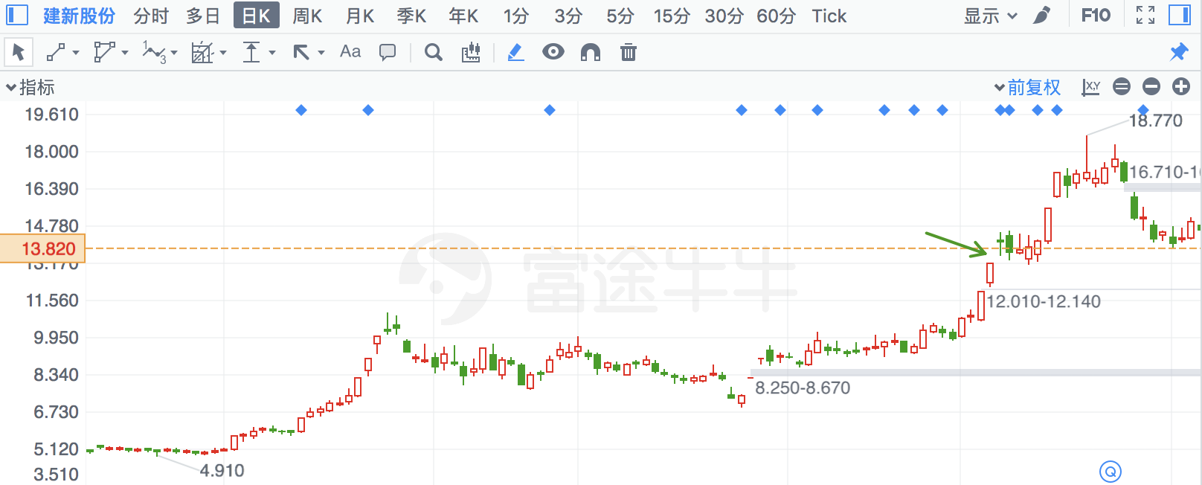

## 两面针

|  |  |  |  |
| --- | --- | --- | --- |
| 2018/5/28 | 600249 | 两面针 | **-7.82%** |

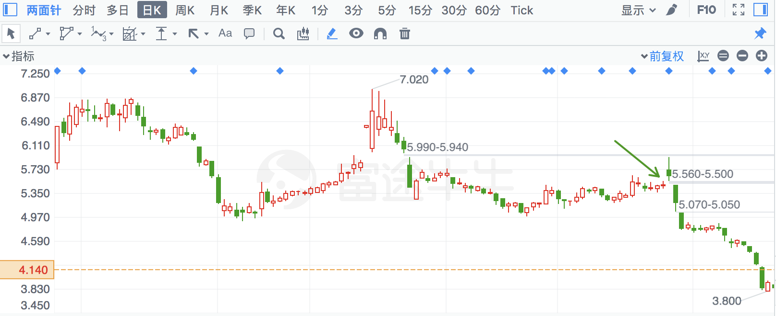

## 旭升股份

|  |  |  |  |
| --- | --- | --- | --- |
| 2018/7/10 | 603305 | 旭升股份 | **-7.81%** |

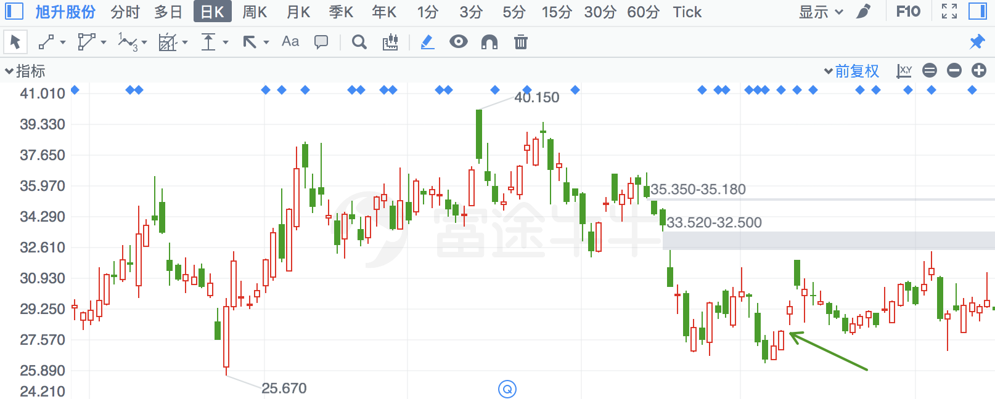

## 爱乐达

|  |  |  |  |
| --- | --- | --- | --- |
| 2018/3/28 | 300696 | 爱乐达 | **-7.77%** |

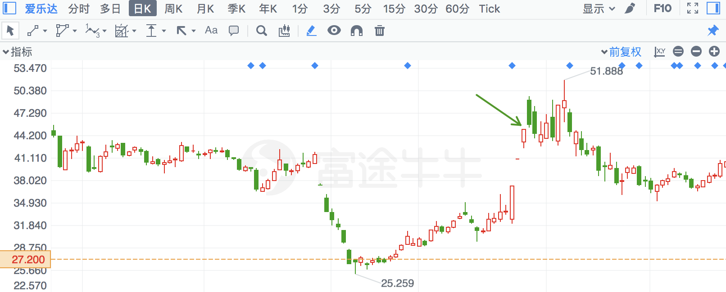

## 卫光生物

|  |  |  |  |
| --- | --- | --- | --- |
| 2018/7/16 | 2880 | 卫光生物 | **-7.75%** |

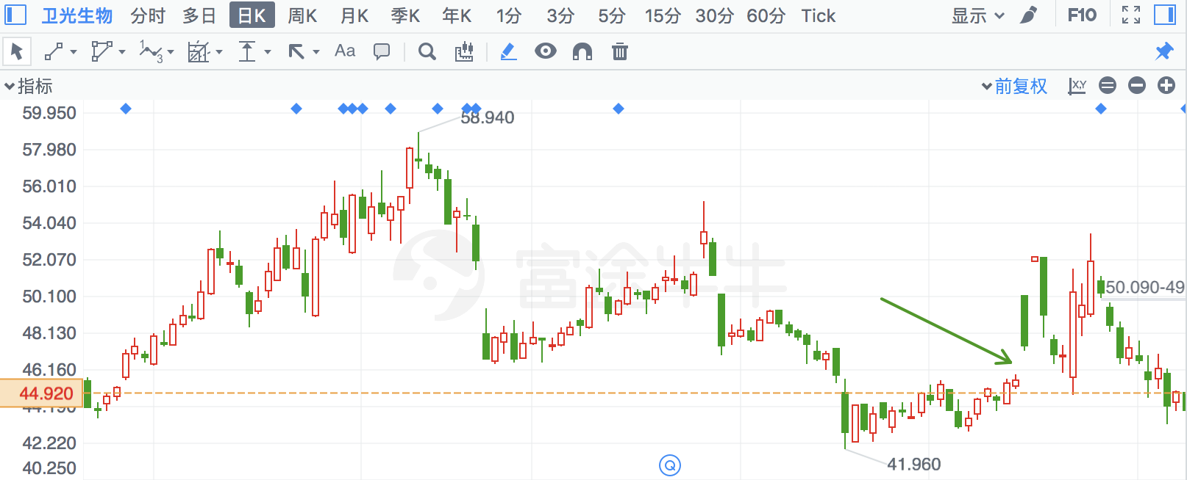

## 金杯汽车

|  |  |  |  |
| --- | --- | --- | --- |
| 2018/6/14 | 600609 | 金杯汽车 | **-7.72%** |

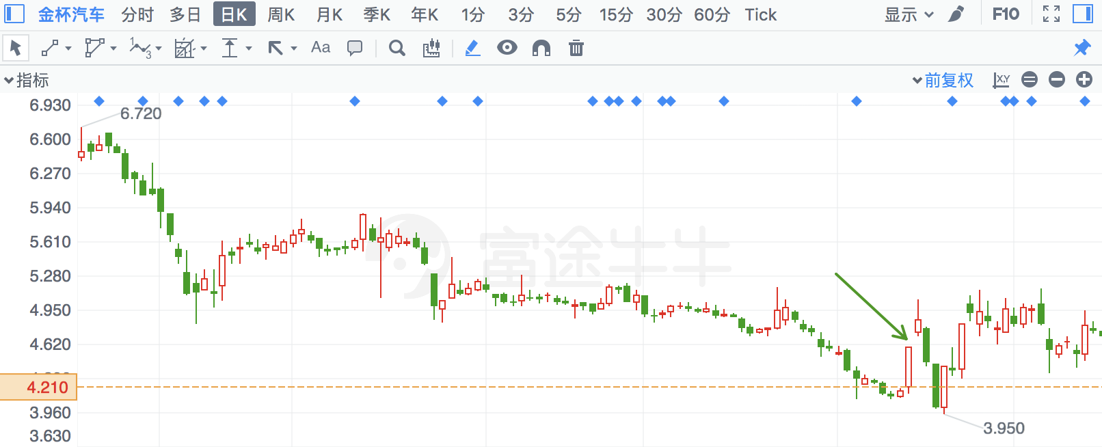

## 神州数码

|  |  |  |  |
| --- | --- | --- | --- |
| 2018/6/13 | 34 | 神州数码 | **-7.62%** |

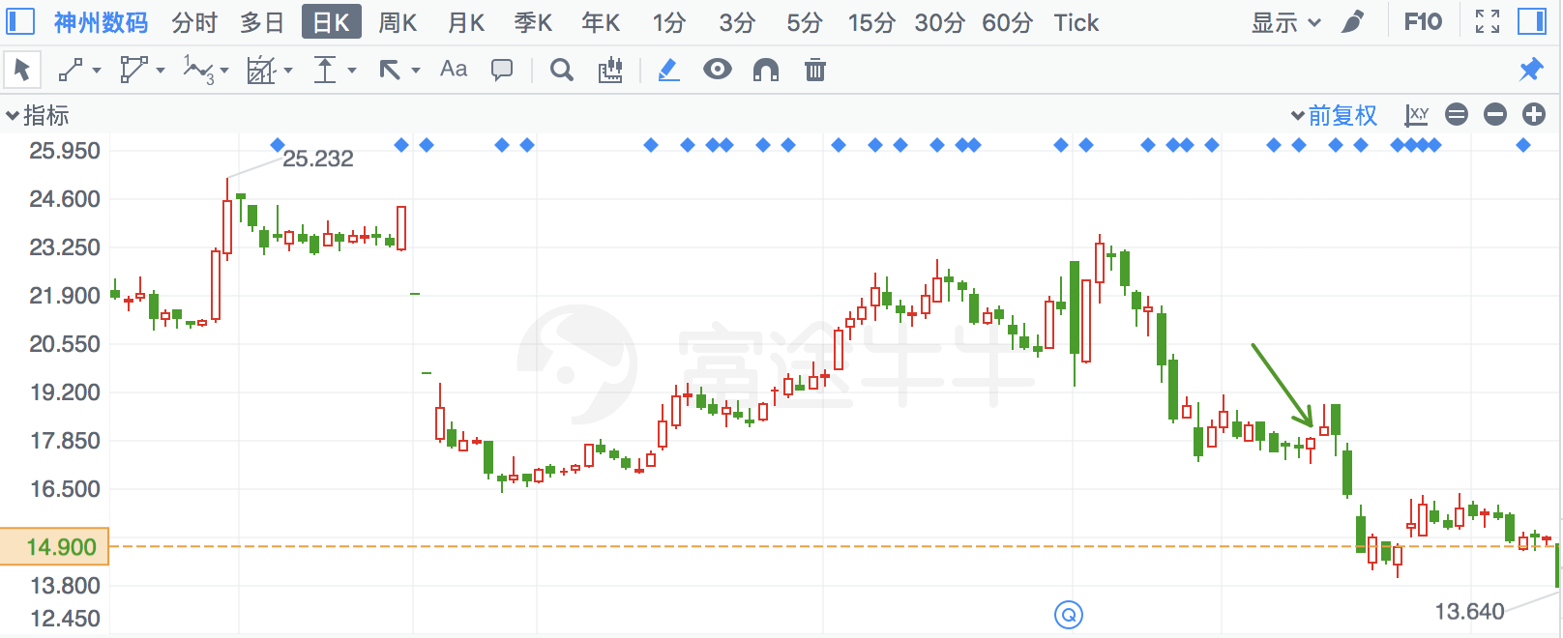

## 保隆科技

|  |  |  |  |
| --- | --- | --- | --- |
| 2018/7/10 | 603197 | 保隆科技 | **-7.56%** |

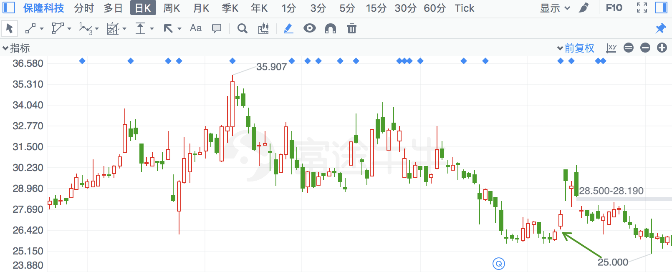

## 百洋股份

|  |  |  |  |
| --- | --- | --- | --- |
| 2018/1/31 | 2696 | 百洋股份 | **-7.53%** |

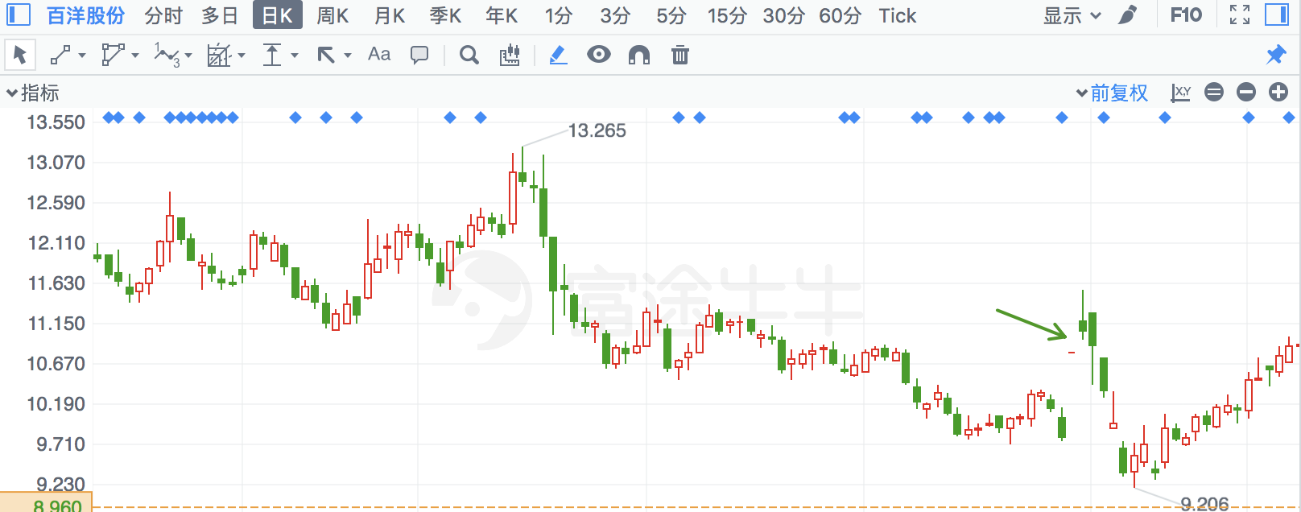

## 三特索道

|  |  |  |  |
| --- | --- | --- | --- |
| 2018/4/16 | 2159 | 三特索道 | **-7.50%** |

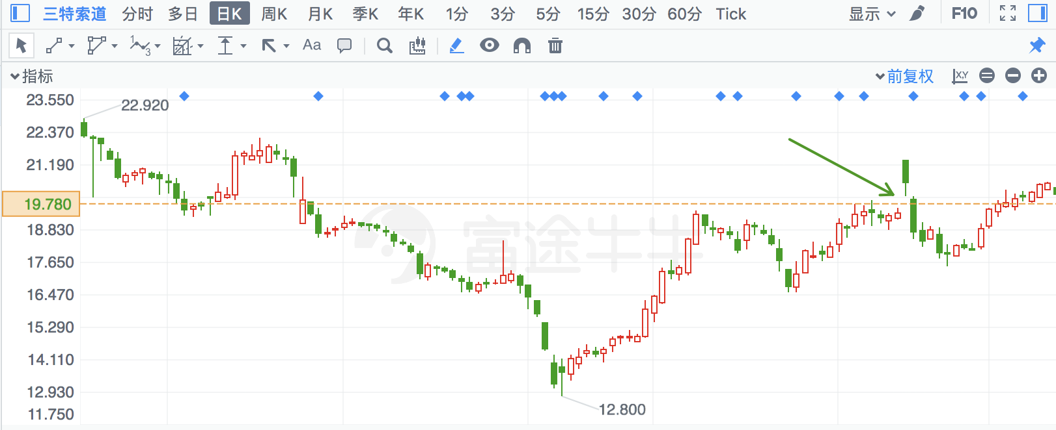

## 世纪鼎利

|  |  |  |  |
| --- | --- | --- | --- |
| 2018/7/3 | 300050 | 世纪鼎利 | **-7.48%** |

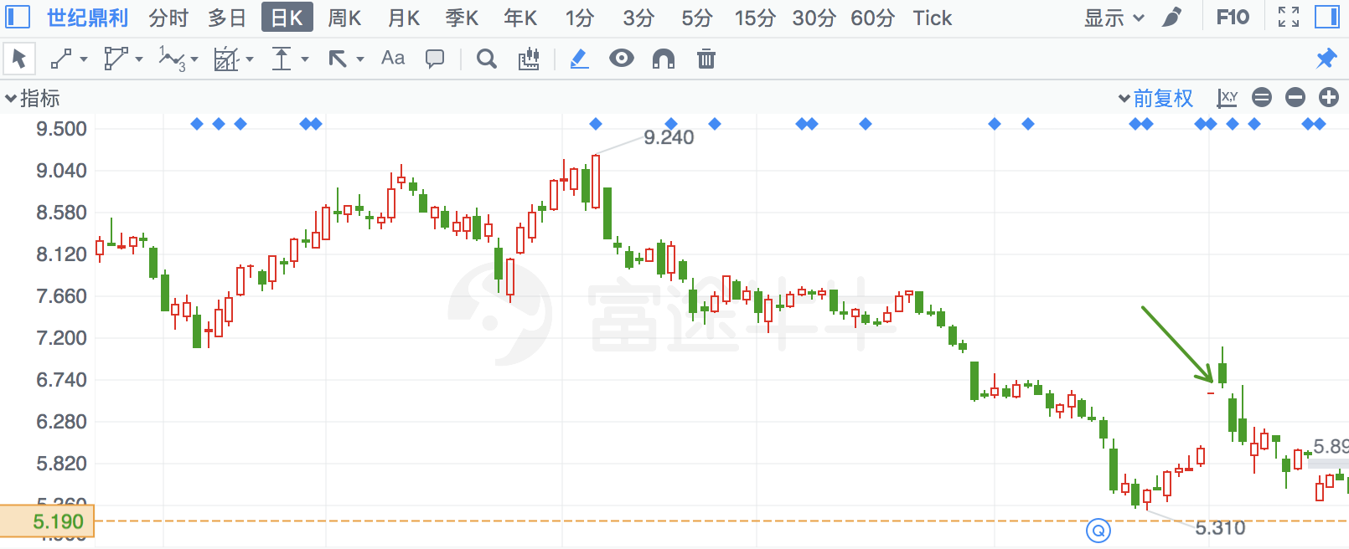

## 佳都科技

|  |  |  |  |
| --- | --- | --- | --- |
| 2018/3/16 | 600728 | 佳都科技 | **-7.47%** |

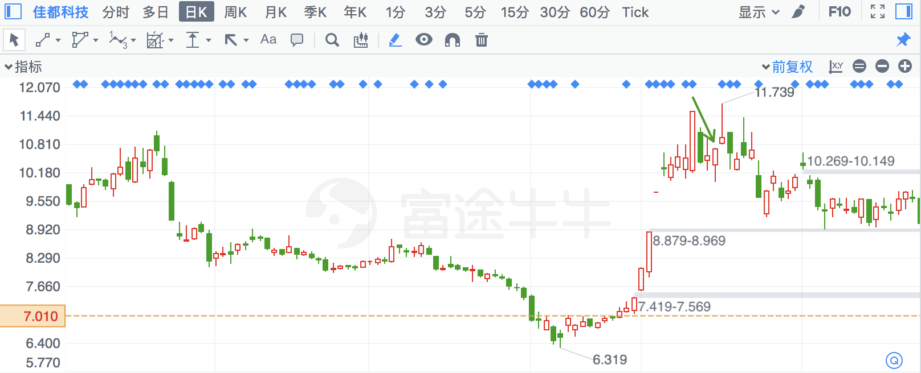

## 卫信康

|  |  |  |  |
| --- | --- | --- | --- |
| 2018/5/23 | 603676 | 卫信康 | **-7.20%** |

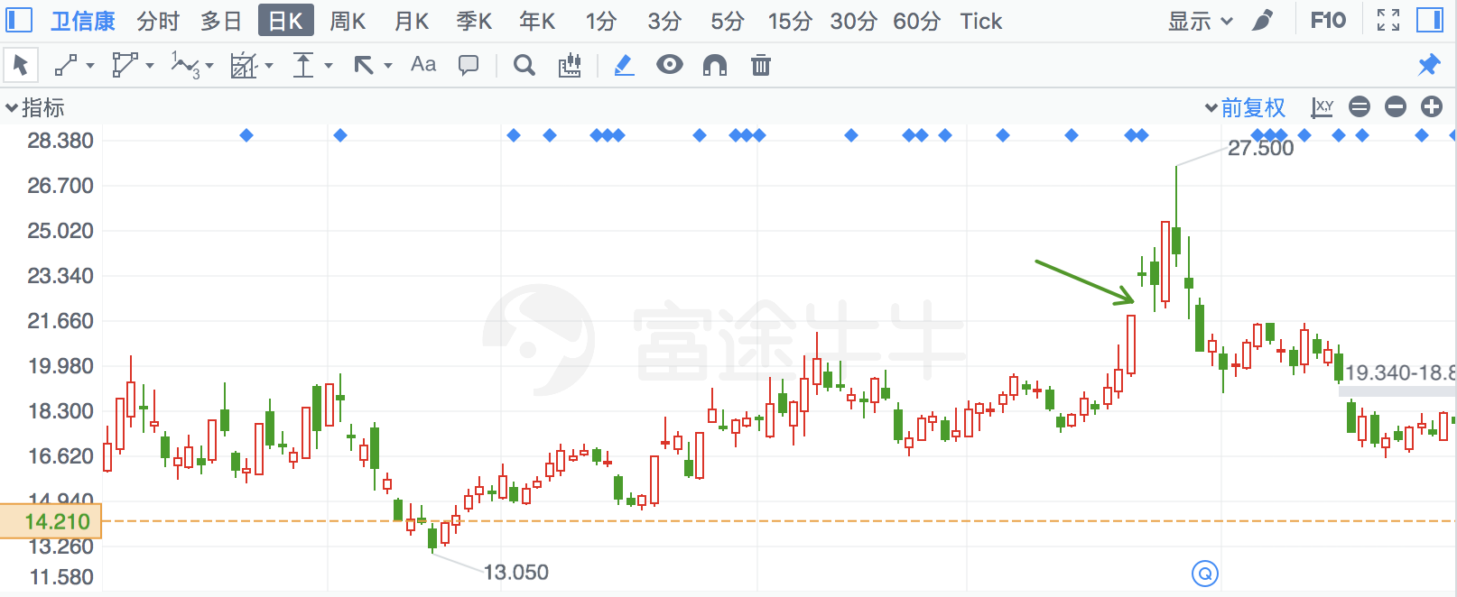

## 石英股份

|  |  |  |  |
| --- | --- | --- | --- |
| 2018/7/17 | 603688 | 石英股份 | **-7.17%** |

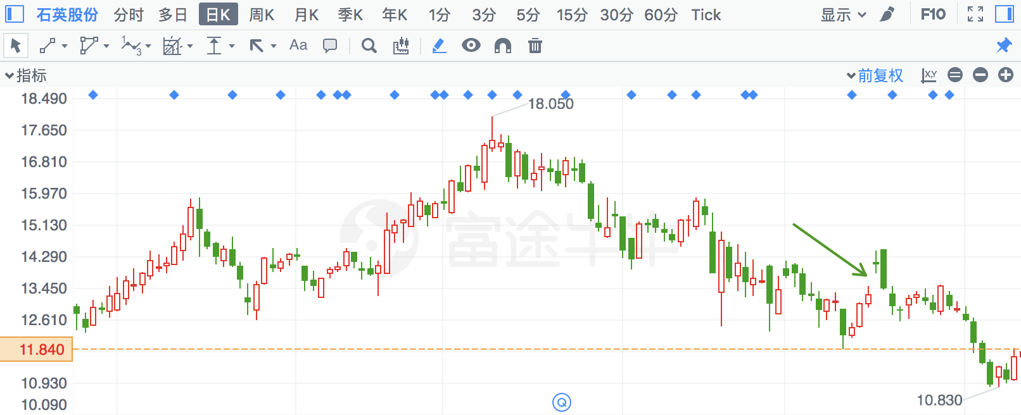

## 大恒科技

|  |  |  |  |
| --- | --- | --- | --- |
| 2018/4/26 | 600288 | 大恒科技 | **-7.16%** |

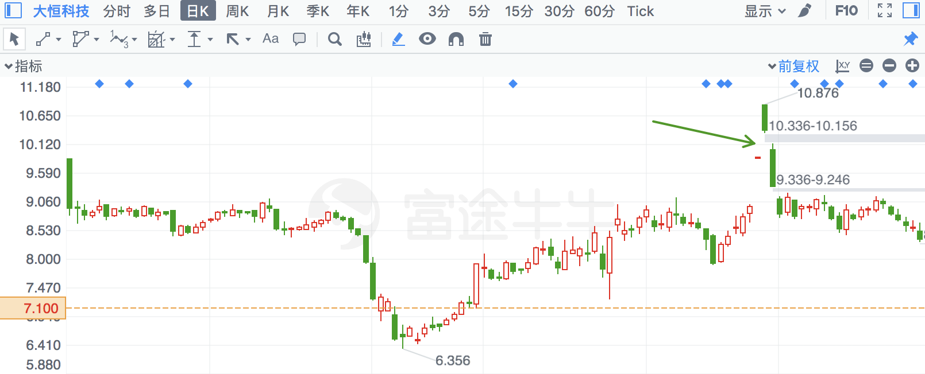

## 路通视信

|  |  |  |  |
| --- | --- | --- | --- |
| 2018/4/26 | 300555 | 路通视信 | **-7.14%** |

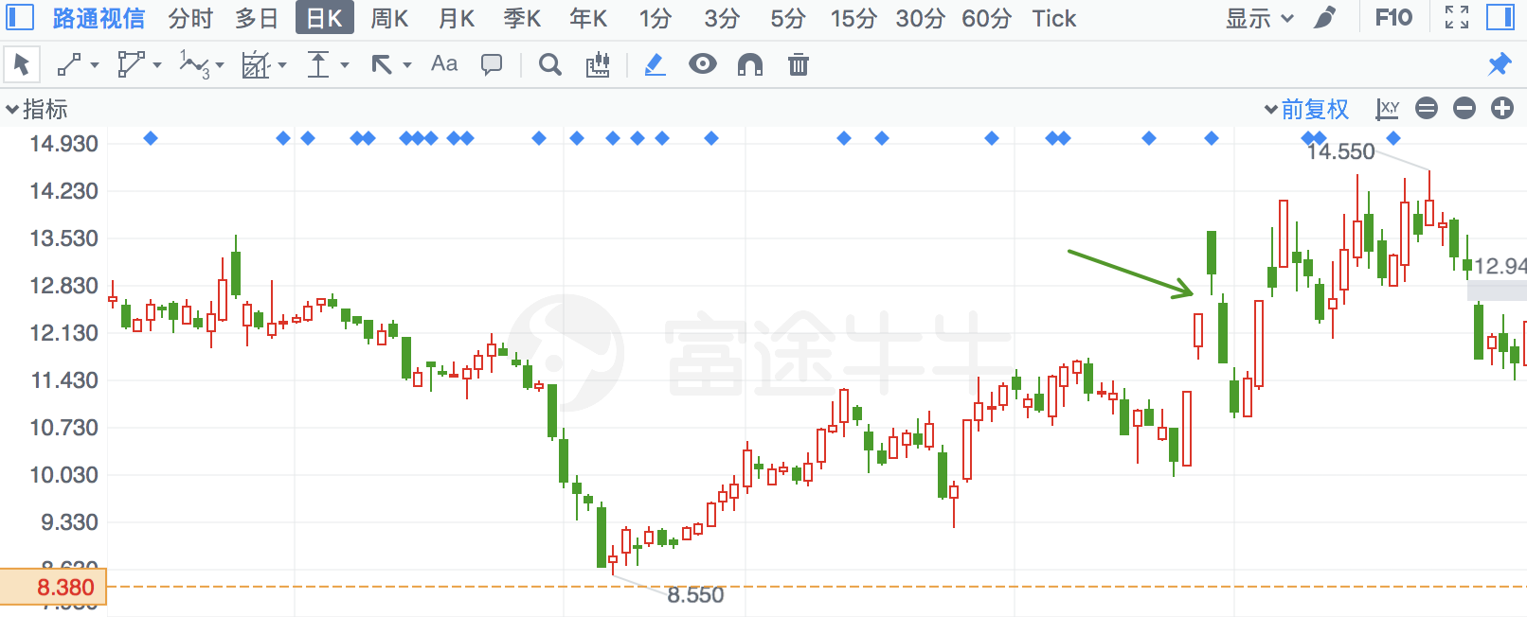

## 深冷股份

|  |  |  |  |
| --- | --- | --- | --- |
| 2018/7/4 | 300540 | 深冷股份 | **-7.09%** |

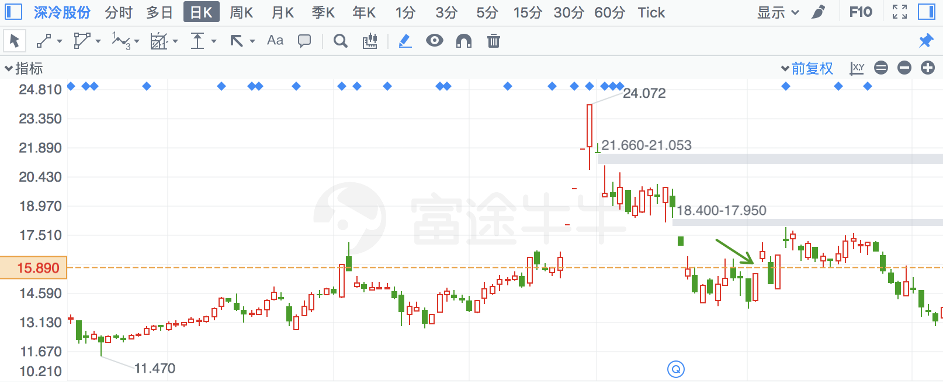

## 保变电气

|  |  |  |  |
| --- | --- | --- | --- |
| 2018/6/15 | 600550 | 保变电气 | **-7.08%** |

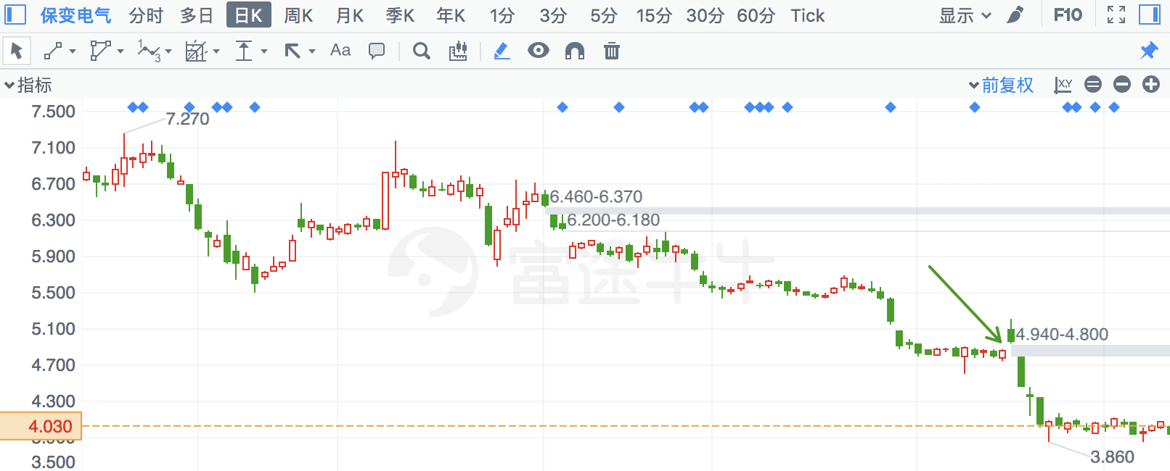

## 电工合金

|  |  |  |  |
| --- | --- | --- | --- |
| 2018/6/6 | 300697 | 电工合金 | **-7.03%** |

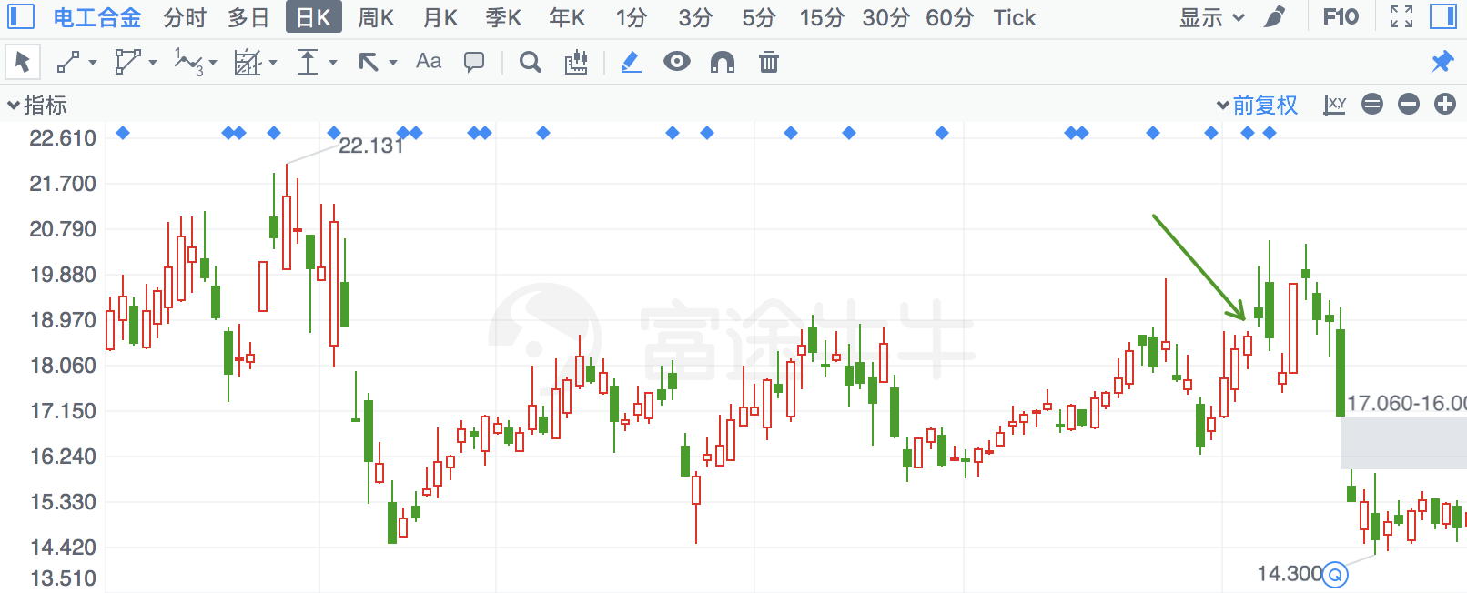

## 中矿资源

|  |  |  |  |
| --- | --- | --- | --- |
| 2018/3/22 | 2738 | 中矿资源 | **-7.01%** |

